**Host a website on ec2-server:**

1. **Lanuch 1 ec2-instance with linux AMI:**
2. **Add security group –allow HTTP 80 port:**

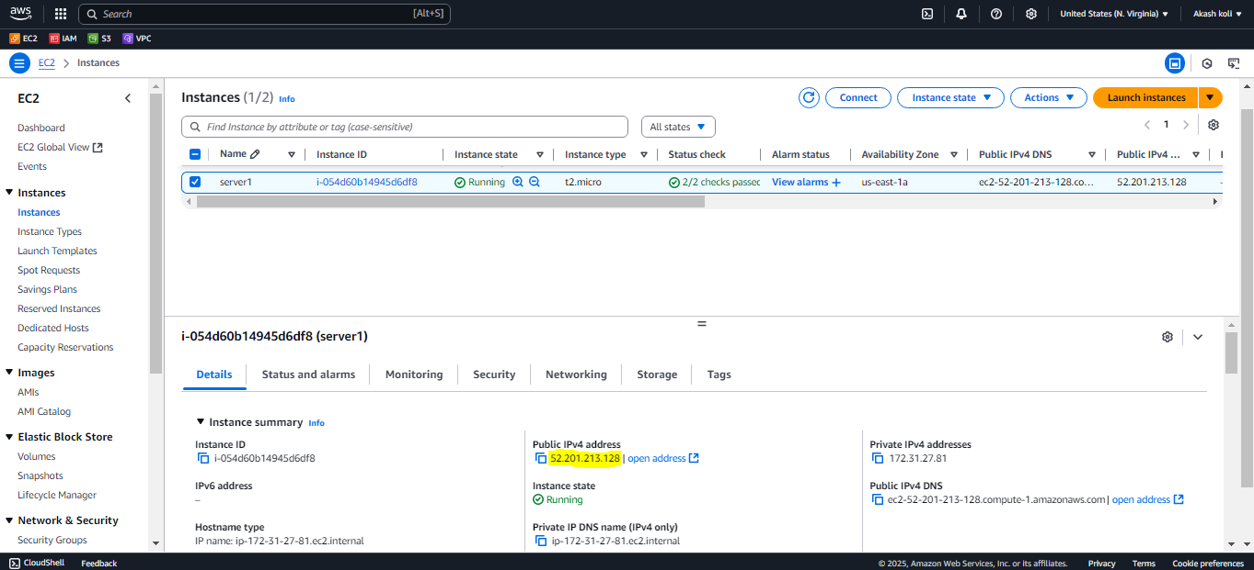

**2. Download free css template in your system**

**3. Upload the Files to EC2:**

From your terminal,(Local system) run:

**scp -i your-key.pem -r /path/to/unzipped/neogym/* ec2-user@your-ec2-public-ip:/tmp/**

**4. Then SSH your instance**

**ssh -i your-key.pem ec2-user@your-ec2-public-ip**

**sudo cp -r /tmp/* /var/www/html/**

**sudo chmod -R 755 /var/www/html/**

**5. Check the server ip address on website :**

